OK registration

Added on July 27, 2018.

1. 1. Log in using by link <https://ok.ru/>.



2. Under the link https://ok.ru/devaccess get the rights of the developer.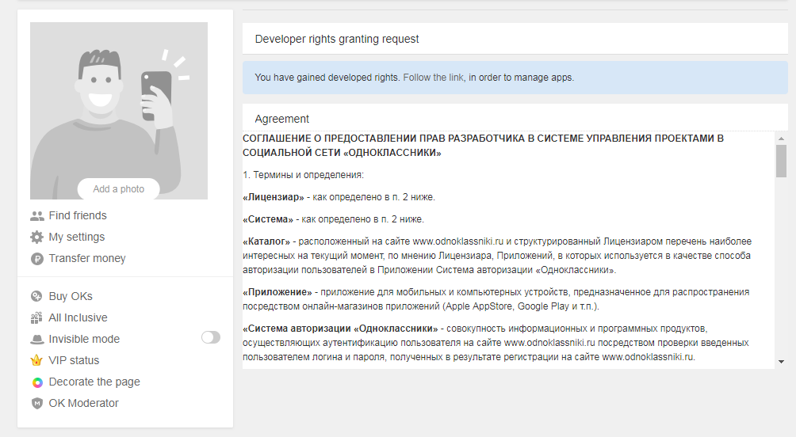

1. Next you need to follow the link <https://ok.ru/vitrine/myuploaded>.  
   In the window that opens, click on the "Add app" button.

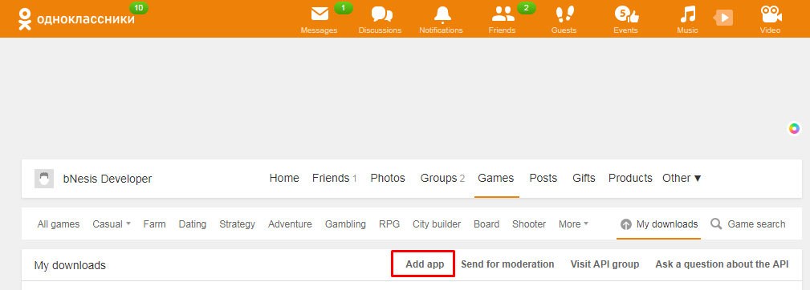

4. Next, you must specify the name of the application.

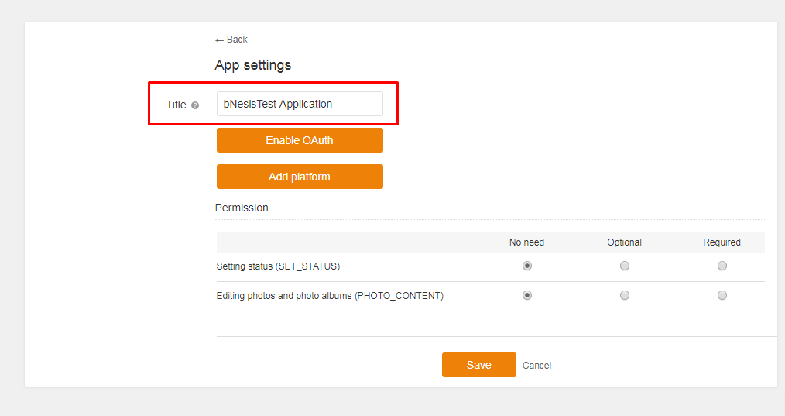

5. After that, click the Enable OAuth button.

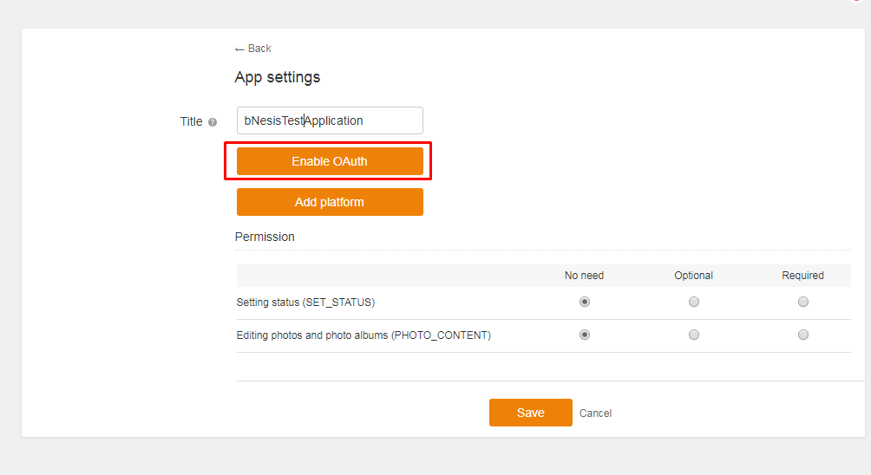

6. In the List of permitted redirect_url field, you need to add a list of allowed redirects to obtain the access keys.

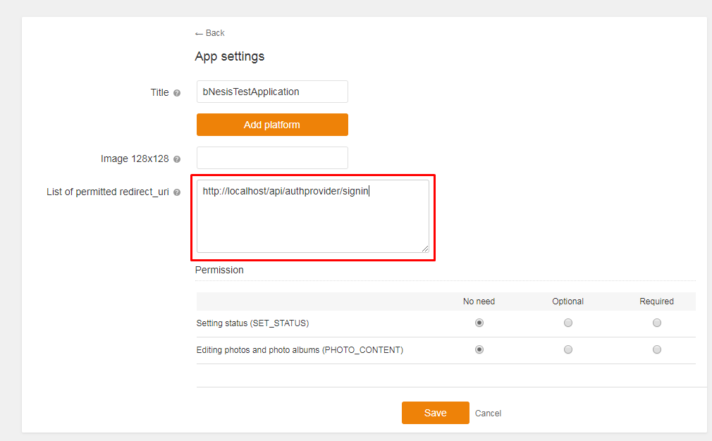

7. Click the Add button.

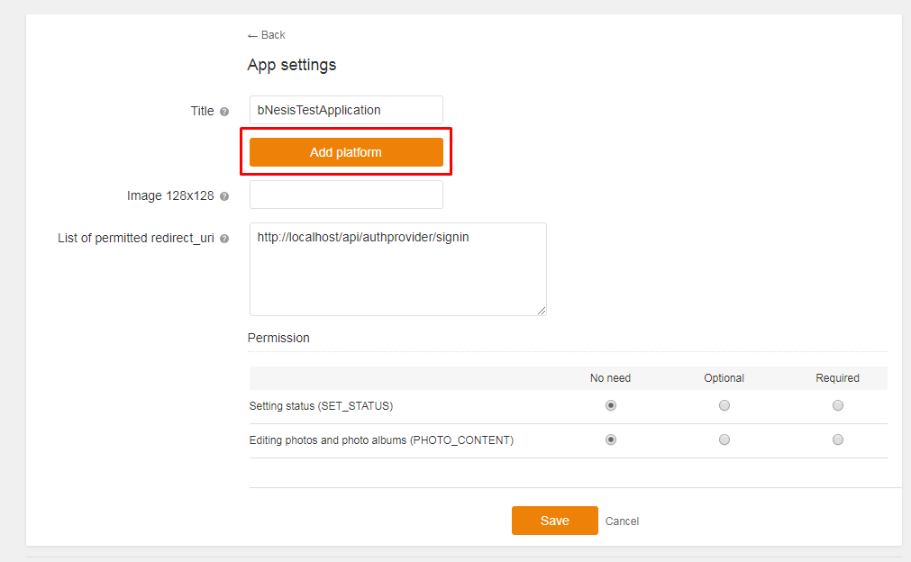

8. In this window, select Application type HTML (Mobile) and External.

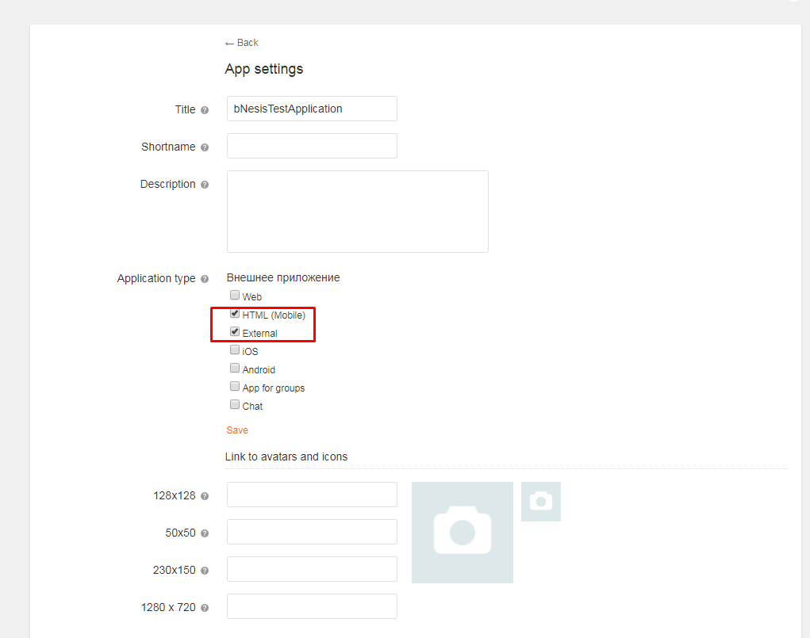

9. Fill in the required fields.

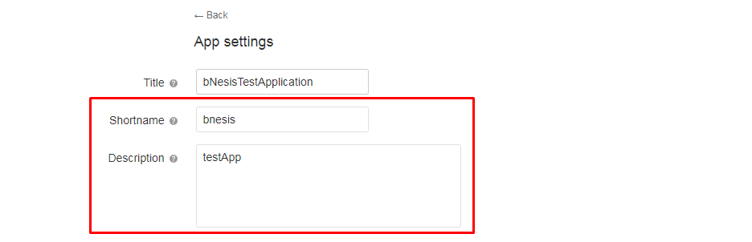

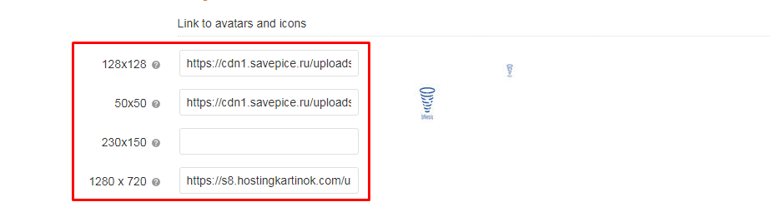

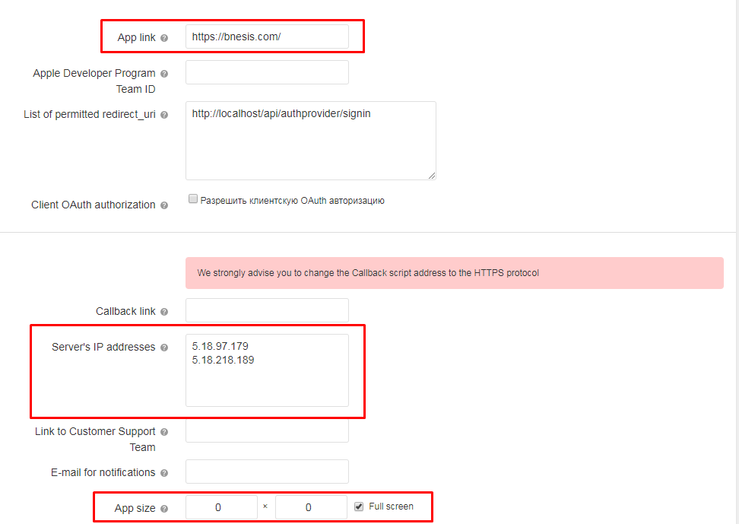

10. Select the necessary rights for the application. 

11. Click on "Save".

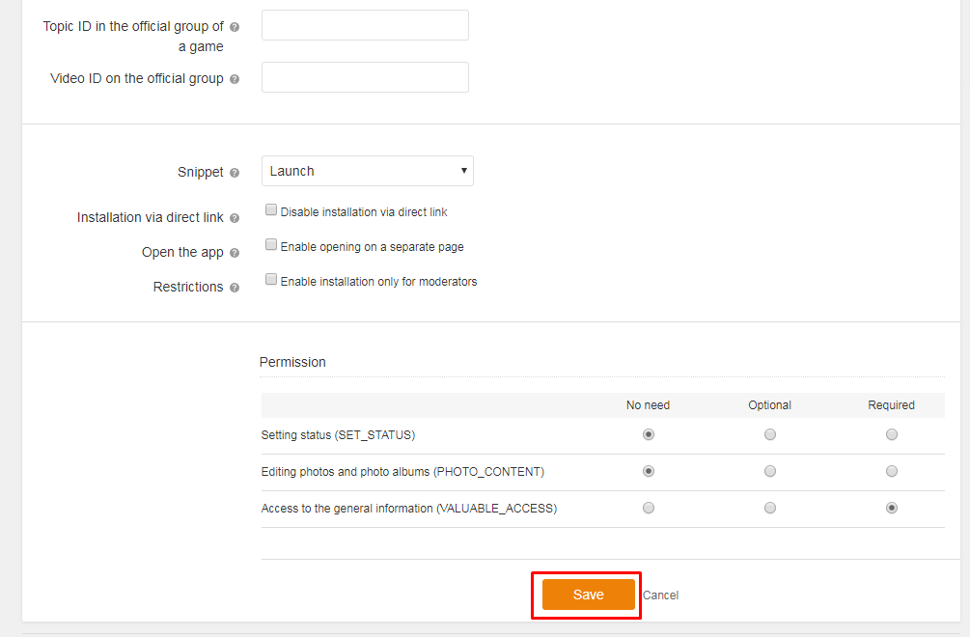

12. After this, a letter with the necessary keys will come to the e-mail specified during registration.

13. To complete the procedure, contact the administration of the resource by e-mail api-support@ok.ru for permission to use the registered application.